**Unit: 1**

**System Development Environment**

**System**

* System is an orderly grouping of interdependent components or elements linked together according to a plan to achieve a specific objective.
* System elements are input and output, processing, control, feedback, boundaries, Environment

System

Output

Input

* System analyst also divides the system into sub-systems to make design and analysis part easier. So, it also needs sub-system integration.

Sub-system1

Sub-system 2

System

Sub-system1

Sub-system 2

**Types of System:**

* **Deterministic and probabilistic System:**

1. Those systems where one can predict the occurrence of events perfectly are called deterministic systems. E.g.: Production system like automobile production.
2. Those systems where one cannot predict the occurrence of events perfectly are called probabilistic systems. E.g.: closing balance of cash in a hotel reservation office.

* **Closed and open system**

1. Degree of independence gives the system that can be open or closed system.
2. Closed system means self-contained or independent system that doesn’t interact with its environment.
3. Changing environment doesn’t affect or less impact on closed system. (Closed)
4. Open System has many interfaces with its environment, it does interact with its boundaries. It means it is dependent on many things like inputs or environment.

**Characteristics of open system:**

* Inputs from outside.
* Open system resist entropy. It means to seek new inputs or modifying the processes to return to a steady state.
* Process, output and cycles: open systems produce useful output and operate in cycles, following a continuous flow path.
* Feedback mechanism by which it imports information from the environment.
* Differentiation: Old patterns are changed by new specialized functions.
* Integration and co-ordination between various parts.
* Equifinality: It means, the system can reach the same final state from different initial conditions and by a variety of paths.

**Characteristic of system:**

1. **Organization**
   1. System is in an orderly structural manner.
   2. Arrangement of components that helps to achieve objectives.
2. **Interactions:**
   1. One sub-system or component functions interact with other one components of system to meet objectives.
3. **Interdependent**
   1. Parts or components of the organization or system are coordinated and linked together according to a plan.
   2. One sub-system depends on the output of another sub-system for proper functioning.
4. **Central objective**
5. **Integration:** It means how a system is tied together.

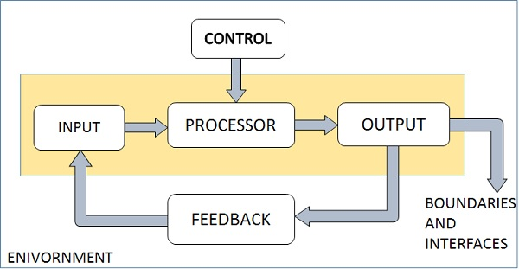

Fig: Control Mechanism

**System Analysis:**

* System analysis is a method for identifying and solving problems that looks at each component in the over system for achieving specific goals.
* System analysis can include looking at end user implementation of a software package or product; looking in-depth at source code to define the methodologies sued in building software or taking feasibility studies and other types of research to support the use and production of a software product.
* Systems analysis is the process by which an individual(s) studies a system such that an information system can be analyzed, modeled and a logical alternative can be chosen.
* System analysis projects are initiated for three reasons

1. Problems
2. Opportunities
3. Directives

* Process by which system are developed can be described by the SDLC.
* The tasks, technique and tools used by the system developed life cycle can be referred as a methodology.
* Three Classification of methodologies:

1. Traditional
2. Information engineering
3. Object-oriented

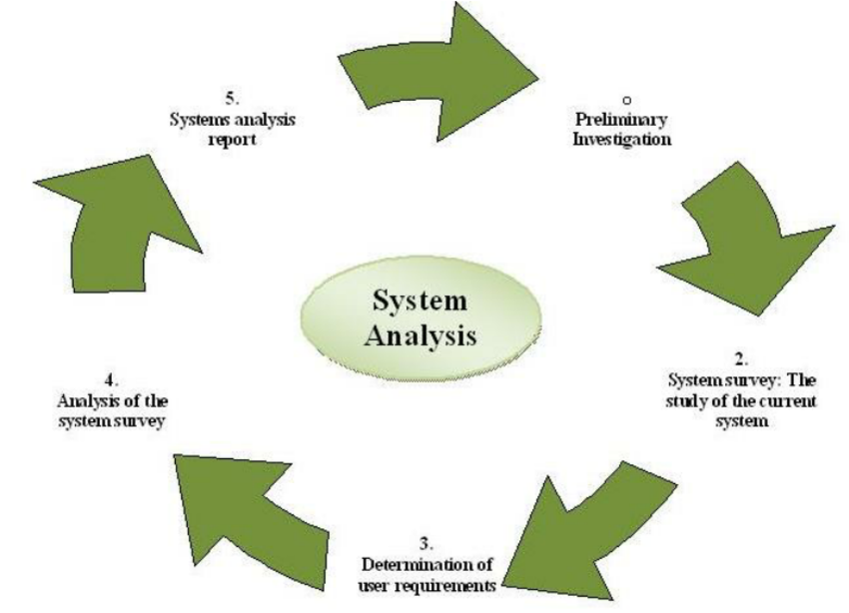­­­­

**System Analysis Phases:**

1. **Research methods:** Specific procedures or techniques used to identify, select, process and information about a topic.
2. **Identification of problem:** Finding complexity, weakness, challenges of the system that is in use or in developing phase.
3. **Description of current system:** Explanation of the functionality, algorithms of its work, objects that interact with it.
4. **Identifying user needs:** Identifying user needs are aspects of the current system that require improvements or new features

**System Analysis techniques**

1. Block diagram
2. Fault tree analysis
3. Event tree analysis
4. Cause-consequence diagram
5. Human error analysis
6. Decision tables
7. Decision tree
8. System flow chart
9. Grid charts

* **Block Diagram analysis**

It is usually used for simple system. Block diagram is a graphical representation of a system. It provides a functional view of a system. It is heavily used in engineering. E.g., Software design, electronic design, process flow diagram.

**Elements in Block Diagram Analysis**

* Block: Logical and physical system components
* Standard part: point of interaction between a system block and its environment
* Reference and part: all parts that have been modelled using aggregation and association
* Relationships with block diagrams by composition and generalization.

**Roles of System Analyst**

System analyst is a person who uses analysis and design techniques to solve business problems using information technology.

1. Defining user requirements
2. Prioritizing requirements by using analytical and logical skills
3. Identifying problems and removes unnecessary details to called problem analysis
4. Drawing specifications by assigning relevant responsibilities of managing system requirements to right individuals and team members.
5. Documentation of system tasks and review the output.
6. Evaluates the system by differentiating the weakness, strength, opportunity, threat of the system.
7. Keeping up to date with technological advancement.

**Skills of a system analyst**

1. Strong analytical skills and critical thinking
2. Attention to detail and technical analysis
3. Teamwork details and management
4. Written and verbal communication skills
5. Interpersonal skills
6. Flexibility
7. Adaptability
8. Business Analytics

**System Design**

* System design is the process of designing the elements of a system such as the architecture, modules and components, interfaces of those components and the data that goes through that system based on the specified requirement.
* Systematic approach is required for a coherent and well-running system. System design can sue both Top-down and bottom-up or Hybrid strategies.
* Designs can be defined in graphical or textural modelling languages.
* E.g., Unified modelling language (UML), flowchart, Business Process Modelling Notation (BPMN), System Modelling Language (SML)

**System Design Methods**

1. **Architectural design:** To describe the views, models, behavior and structure of the system. Defines relationship between various methods of system development process.
2. **Logical design:** To represent the data flow, inputs and output of the system. E.g., ER diagram.
3. **Physical design:** It relates to the actual input and output processes of the system. It focuses on how data is entered into a system, verified, processed and displayed as output.

**Major tasks performed during the system design process**

1. **Initialize design definition:**
   1. Identify the technologies and implement the system elements and their physical interfaces
   2. Document the design definition.
2. **Establish design Characteristics:**
   1. Define the design characteristics relating to the architectural characteristics
   2. Define the interfaces, modules, components etc.
   3. Document the design characteristics of each system elements.
3. **Asses alternatives for obtaining system**
   1. Asses the design options
   2. Select most appropriate alternatives
4. **Manage the design**
   1. Control the evolution of the design characteristics
   2. Maintain rationale for all selections for the design, architecture characteristics.

**Two Strategies for system design**

1. Bottom-up Strategies
2. Top-down Strategies

**Three approaches to implementing system design**

1. **Structured design approach:**
   1. Mostly based on divide and conquer strategy where a problem is broken into several small problems and each small problems is individually solved until whole problem is solved
   2. Small modules are designed and arranged in hierarchy modules communicate with each other.
   3. Good structured design has high cohesion and low coupling arrangements.
2. **Function Oriented design:**
   1. Similar to structured design but instead divides the entire system into sub-systems referred to as functions.
   2. Whole system is seen as how data flows int eh system by means of data flow diagram.
   3. Data flow diagram depicts how functions change data. E.g., DFD, Data dictionaries, structure charts.
3. Object Oriented design:
   1. Here, entities and their characteristics are used to define.
   2. Concept of OOP are used. They are objects, classes, encapsulation, inheritance, polymorphism

**Information system and its types**

1. Data are the collection of raw facts representing events and information is the data shaped into a meaningful form.
2. Information system produce information by using data about significant people, places and things from withing the organization and/or from the external environment to make decisions, control operations, analyze problem and create new products or services.
3. Three activities in information system
   1. Input
   2. Processing
   3. Output
   4. Feedback

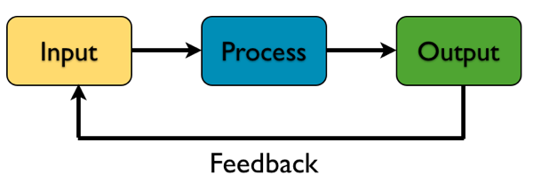

**Two types of Information System:**

* 1. **Formal Information System**
     1. Based on accepted and fixed definitions of data and procedures for collecting, storing, processing, disseminating an using these data with predefined rules. E.g.: Manual Information System (i.e., needs pen and pencil), computer Based Information System (CBIS).
  2. **Informal Information System:**
     1. Relay on unstated rules
     2. Designed to meet personal and d vocational needs and to help in the solution of work-related problems.

**Information System Analysis and Design**

Information systems analysis and design is a complex, challenging and simulating organizational process that a team of business and systems professionals uses to develop and maintain computer-based information systems.

**Format and Computer based Information System (CBIS)**

This category of IS depends mainly on computer for handling business applications. They can be classified as:

**Types of Information Systems:**

1. **Management Information System (MIS)**
   1. System works at management level of an organization and serve management level functions like planning, controlling and decision-making.
   2. These systems use internal data provided by the transacting processing systems.
   3. Operationally, MIS should provide for file definition, file maintenance and updating transaction processing.
   4. Primary users of MIS are middle and top management, operational managers and support staff.
   5. Mostly used for preparing forecasts, special requests for analysis, periodic reports.
   6. E.g., salary analysis and sales reporting
2. **Decision Support System (DSS)**
   1. DSS advances the capabilities of Mis and provides services of decision making
   2. DSS combines data and sophisticated analytical models or data analysis tools to support semi-structured and unstructured decision-making.
   3. Use internal information from TPS and MIS and often information from external sources such as stock prices or product prices of competitors.
3. **Transaction Processing Systems (TPS)**
   1. Perform and records the daily routine transaction necessary to conduct business
   2. Serve the operational level of the organization.
   3. E.g.: including sale order entry, hotel reservation system, payroll, employee record keeping and shipping.
4. **Executive information System (EIS)**
   1. Also called Executive support systems (ESS) and serve the strategic level of organization.
   2. Designed to address unstructured decision making through advanced graphics and communication.
   3. E.g.: Drill-down analysis.
5. **Expert System:**
   1. Extension of DSS that captures an reproduces the knowledge and expertise of an expert problem solution or decision maker and then simulates the “thinking” or “actions” of that expert.
   2. E.g.: XCON (Expert configure)
6. **Communication and collaboration systems**
   1. Enable more effective communications between workers, partners, customers and suppliers to enhance heir ability too collaborate
   2. Uses network technology for communication and collaboration
   3. E.g.: Video Conferencing, web survey system.
7. **Office Automation System**
   1. It includes word processing, spreadsheet, applications, emails, work group computing, fax processing, work flow management

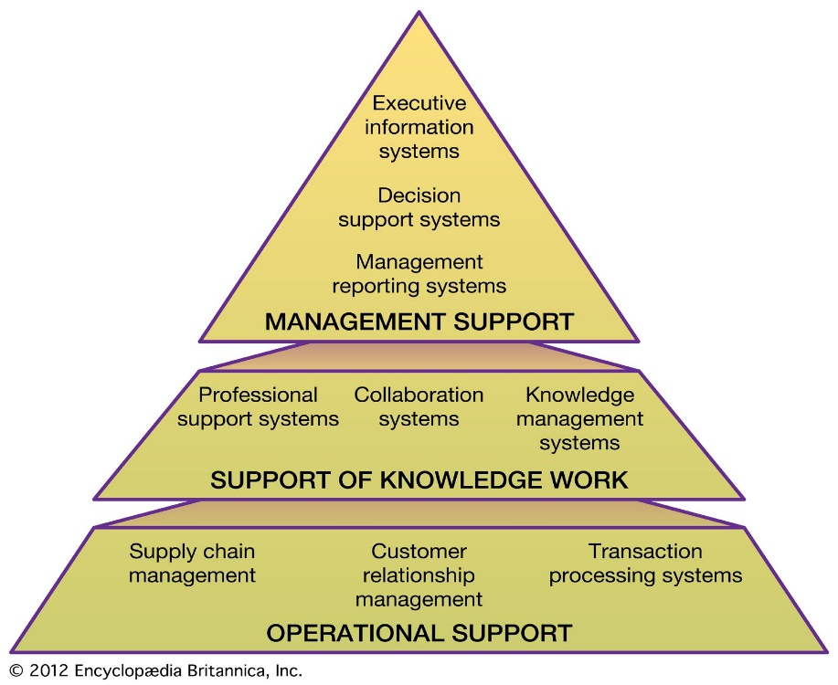

Fig: Information System

**Developing Information Systems**

* Information system development is also known as system life cycle (SDLC) or software development life cycle (SDLC).
* Systems development methodology is a standard process followed in an organization to conduct all the steps necessary to analyze, design, implement and maintain information systems.
* SDLC is a traditional methodology used to develop, maintain and replace information systems.
* Phases of SDLC:

1. Planning
2. Analysis
3. Design
4. Implementation
5. Maintenance

* 7 steps of SDLC

1. Identifying problems, opportunities and objectives
2. Determining human information requirements
3. Analysis system needs
4. Designing the recommended system
5. Developing and documenting software
6. Testing and maintaining the systems

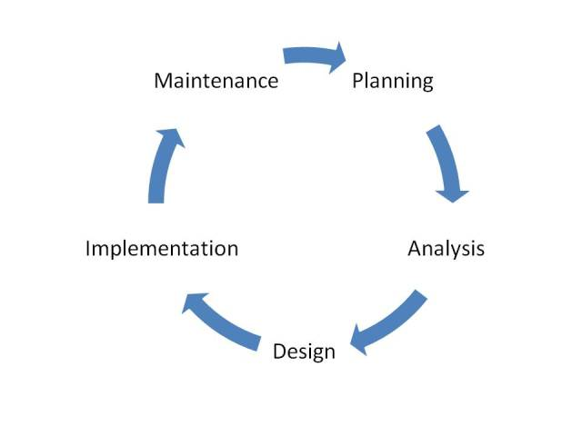

Fig: 5 Phases of SDLC

**Planning (Phase 1)**

* First phase of the SDLC in which an organization’s total information system needs are identified, analyzed, prioritized and arranged
* Focus: Why build this system? And how to structure the product?
* Primary output: 1. System request with feasibility study 2. project plan

Steps:

* Identifying opportunity
* Analysis feasibility
* Develop work plan
* Staff project
* Control and direct project

**Analysis (Phase 2)**

* Here, system requirements are studied and structured.
* Focus: Who, what, where and when for this system?
* Primary outputs: system proposal
* Steps:
* Develop analysis strategy
* Determine business requirements
* Create use cases
* Model processes
* Model data

**Design (phase 3)**

* Converting the description of recommended solution into logical and then physical system specifications
* Part of design process that is independent of any specific hardware or system platform is referred to as logical design.
* Once the overall high-level design (logical design) of the system is worked out, the analysts begin turning logical specifications into physical ones and this is called physical design.
* Focus: How will system work?
* Primary outputs: System specification
* Steps:
* Design logical system and physical systems
* Design architecture
* Design interface
* Design programs
* Design database and files

**Implementations (phase 4)**

* The physical system specifications whether in the form of a detailed model or as detailed written specification are tuned over to programmers as the first part of implementations phase; second one part is testing and last one part is installation.
* Implementation includes coding, testing and installation
* Focus: Delivery and support of completed system
* Primary outputs: installed system
* Steps:
* Construct system
* Install system
* Maintain system
* Post-implementation

**Maintenance (phase 5)**

* Here, an information system in systematically repaired and improved.
* It is important part because wherever, the business purpose or user requirement or any problems on system is raised then this phase provides flexibility, scalability, efficiency, performance etc. of system.

*Note: Heart of systems development process are Analysis 🡪 Design 🡪 Implementation 🡪*

**Software Development life Cycle methodologies**

1. Waterfall model
2. Iterative waterfall model
3. Prototyping model
4. Incremental model/ iterative model
5. Agile Methodologies (i.e., extreme programming)
6. V-shaped model
7. Spiral model

**Classical Waterfall model**

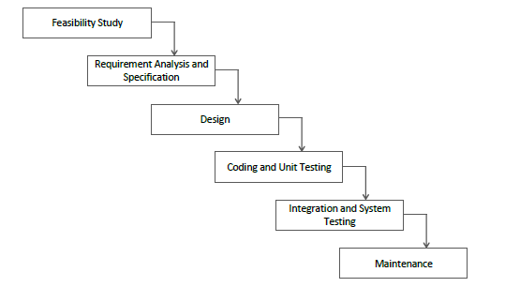

Fig: Classical waterfall model.

**Advantages**

* Basic model/Base model
* Simple and easy
* Used for small projects

**Disadvantages**

* Not feedback system
* No parallelism
* No Risk Management
* Most of efforts on maintenance

**Iterative waterfall model**

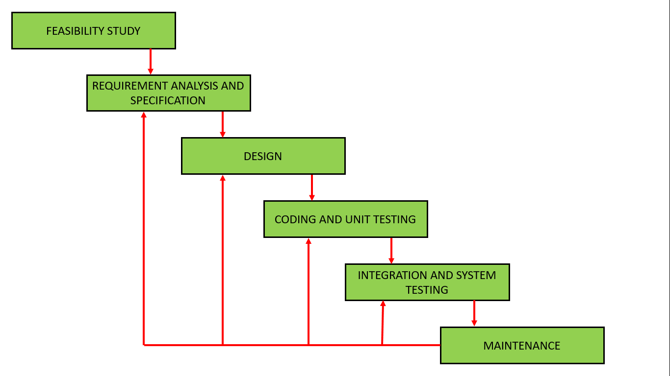

Fig: Iterative Waterfall model

**Advantages**

* Used for small projects
* Have feedback system
* Simple and easy

**Disadvantages**

* No phase overlapping
* Less customer interaction

**Prototyping model**

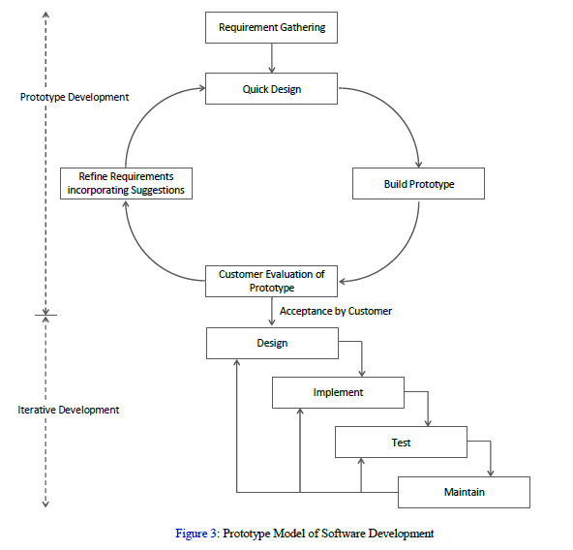

Fig: Prototype Model

**Advantages**

* When customer is not clear with ideas
* Throwaway model

**Disadvantages**

* Good for technical and requirement risks
* Increase in cost of development

**Incremental model / Iterative model**

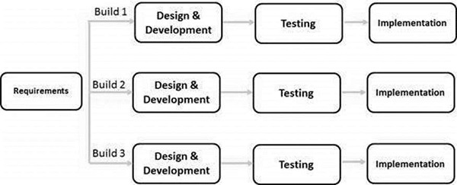

Fig: Incremental model

* Module by module working
* Customer interaction
* Large projects
* Early release product demand
* Flexible to changes

**Spiral model**

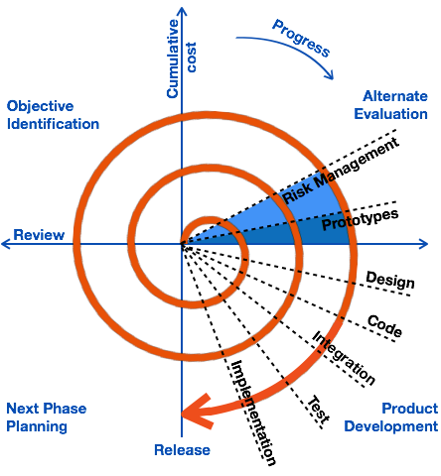

Fig: Spiral model

**Advantages**

* Risk handling
* Used for large projects
* Flexible so, changing requirements can be accommodated
* Customer satisfaction as the suer see the system early
* Allow extensive use of prototypes
* Development can be divided into smaller parts and the risky parts can be developed earlier

**Disadvantages**

* Process is complex
* Spiral may go on indefinitely
* Not suitable for small or low risk projects and could be expensive for small projects

**Phases of spiral model**

1. Identifications
   1. Gathers business requirements
   2. Understanding system requirement by continuous communication with customer and system analyst
2. Design: involves architectural design, logical design of modules, physical product design and the final design in the subsequent spirals.
3. Construct or build: Actual system product at every spiral
4. Evaluation and risk analysis: identifying, estimating and monitoring feasibility and management risks

**Different approaches to improving Development**

* Software engineering: it is a detailed study of engineering to the design, development and maintenance of software. System engineering was introduced to address the issues of low-quality system products. It ensures that the application is built consistently, correctly, on time and on budget within requirements.
* CASE tools, Rapid Application Development (RAD), service-oriented architecture

**Rapid Application Development (RAD)**

* Adaptive system development approaches
* During water or traditional SDLC, the finished product might take months or years to reach the consumer but the RAD, product is continually demonstrated to the user to provide the required input to help enhance it.
* Rad is suited for developing system that is driven by user interface requirement
* A rapid prototype allows the end-users to use the application and give feedback
* Uses minimal planning in favor of rapid prototype
* Most important aspect for this model to be successful is to make sure that the prototypes developed are reusable

**Five phases of RAD**

1. **Business Modelling**
   1. Business model for the product is designed in terms of information flow between different business functions and the distribution of information between various channels
   2. Complete business analysis is done to find vital information.
   3. The information that are gathered from many sources are combined to create a useful description of how the data will be used when it is processed.
2. **Data Modelling**
   1. Information of business model is analyzed and categorized into different groups (data objects)
   2. Attributes of each group are identified and relationship between them is defined.
3. **Process modeling**
   1. Information object defined in the data modeling phase are transformed to achieve the data flow necessary to implement a business function.
   2. Processing descriptions are created for adding, modifying, deleting or retrieving a data object.
4. **Application generations**
   1. Here, all the data gathered is coded, and the system that will be used to build, the prototype is developed.
   2. Actual system is built and coding is done to convert process and data models into actual prototypes
5. **Testing and turnover**
   1. Many of the programming components have already been tested since RAD emphasis reuse. This reduces the overall testing time.
   2. Every prototype is tested separately to modify the components quickly and to create the best product.

**Advantages of RAD**

* Reduced development time
* Encourages customer feedback
* Increases reusability of components
* Integration from very beginning solve a lots of integration issues

**Disadvantages of RAD**

* Needs strong team collaboration
* Needs highly skilled developers
* Needs requirements throughout the life cycle of product
* Only suitable for projects which have a small development time
* More complex to manage when compared to other models.

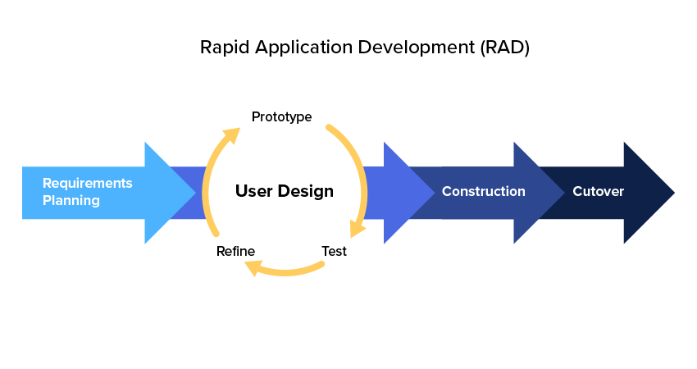

Fig: RAD

**When to use RAD model**

* For projects with clear modularization and delivery
* Incrementally
* Unique projects that have small development time
* When app designers are available for modeling
* For reliable prototype testing. If you have users who can give reliable feedback on prototypes.

**Serve-Oriented Architecture (SOA)**

* Define a way to make system components reusable and inter-operable via service interfaces.
* SOA is an architectural approach in which applications make use of services available in network.
* Idea behind SOA is to build systems around generic services, or specific business functions which can be used in many different applications.
* Developers can assemble the set of services into new applications
* Developing a service is typically done by taking existing code and building a standard interface for it.
* SOA approach have to establish standard for the creation, documentation and maintenance of services.
* Potential benefits of SOA include: facilitation of Rad through service assembly, high return on investment due to reuse of services and ability to access legacy services through the internal or shared communication networks.

**Agile Methodologies**

* 3 key principles

1. Focus on adaptive rather than predictive methodologies
2. Focus on people rather than rules
3. Focus on self-adaptive processes

* People-oriented means it considers the project stakeholders and their feedback as important factors for system development
* Second, agile is adaptive. Any changes to the customer requirements are perceived as good, since it improves the project, team learning.
* Rather than conforming to a detailed plan, it give more importance to the business value-add that each iteration or development cycle gives to the end-users and customers
* It provides high collaboration amongst the team members.
* E.g., Some are adaptive system development, scrum, feature driven development, extreme program

**Agile methodologies suitable for**

* Unpredictable or dynamic requirements
* Responsible and motivated developers
* Customers who understand the process and will get involved

**Extreme Programming**

* It is distinguished by its short cycles, incremental planning approach, focus on automated test written by programmers and customers to monitor (on-site) the development process.
* All phases of the life cycle converge into a series of activities based ont eh basic process of coding, testing, listening and designing.
* Programmers who write the code also develop the tests. So called pair programming.

**Advantages of Extreme Programming**

* More communication between develops
* Higher levels of productivity
* Higher quality code
* Code and test discipline

**Object oriented Analysis and Design**

* Object-Oriented (OO) approach combines data and processes into single entities called objects.
* Concept of inheritance, classes, objects, polymorphism, etc.
* Most popular realizations of iterative approach for OO development is Rational Unified process (RUP).

**CASE Tools**

* Software tools that provide automated support for some portion of the system development process.
* CASE tools can be used to help in the project identification and selection, project initiation and planning, analysis and design phases and / or in the implementation and maintenance phases of SDLC.
* General types of CASE Tools are listed below.

|  |  |  |
| --- | --- | --- |
| SDLC phases | Key activities | CASE Tools Usage |
| Project identification and selection | Display and structure high-level organizational information | Diagramming and matrix tools to create and structure information |
| Project initiation and planning | Develop project scope and feasibility | Repository and documents generators to develop project plans |
| Analysis | Determine and structure system requirements | Diagramming to create process, logic, and data models |
| Design (Logical and physical) | Create system designs | Form and report generators to prototype designs, analysis and documentation generators to define specifications |
| Implementations | Translate designs into an Information System |  |
| Maintenance | Evolve information system |  |

* 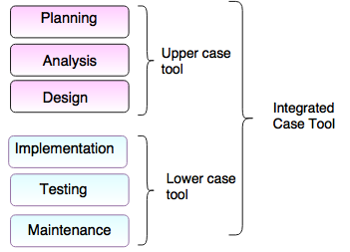

Fig: CASE Tools

* CASE Tools require a central repository, which can serve as a source of common, integrated and consistent information
* Central repository is a central place of storage when product specifications requirement documents, related reports and documents and other information is stored.

**CASE Tools types**

* Diagram tools: Flow chart maker, Block diagram
* Process modelling tools: EPF computer
* Project management tools: Basecamp, creative pro-office used to project planning, coast and effort estimation.
* Documentation Tools: DR Explainx, Doxygen
* Analysis tools: Casecomplete, Accept 361, Allompa
* Design tools: Animated system design
* Configuration management tools: Git, Fossil
* Programming tools: Eclipse, Pycharm
* Prototyping tools: Mockup Bijlder, Screna prototype
* Quality Assurance tools: Soapfest, Jmeter
* Maintenance tools: Bugzilla for defect tracking.

**System Acquisition**

* Internal corporate information systems departments now spend a smaller and smaller proportion of their time and effort on developing systems from scratch.
* Information system are a major corporate asset, with respect to the benefits they provide and to their high costs. Therefore, organization should plan for long tern when acquiring system and services.
* There are 3 ways to create new systems.
  1. Developing a custom application in-house (custom development)
  2. Buying a packaged system (packaging)
  3. Relying on external vendor (outsourcing)

**Software acquisition process involves following steps:**

1. Evaluation of the requirements of information system.
2. Identifying potential vendors and outsourcing provides
3. Evaluation of different alternatives
4. Performing cost-benefit analysis
5. Preparing recommendation
6. Implementing the solution

**Sources of System**

We can group the source of system into six major categories:

1. **Information technology services**

If organization need IS but doesn’t have expertise to develop system in-house and not availability of suitable off the shelf system then the company consult an IT services firm.

1. **Packaged system produces**
   1. Develop system to run on many different computer platforms, from microcomputers to large mainframes
   2. Some of the shelf systems cannot be modified to meet the specific individual needs.
2. **Enterprise Solutions system**
   1. ERP system to support their operations and business processes
   2. ERP consist of series of integrated modules each module is integrated such as accounting, distribution, manufacturing or human resources
3. **Cloud computing**

To obtain applications is to rent them or license them from third-party providers who run the applications at remote sites

1. **Open Sources system**
2. **In-house development**
   1. Spend a smaller and smaller proportion of their time and effort on developing system from scratch
   2. In-house development can lead to a larger maintenance burden than other development methods. Such as packaged applications.

**Choosing Packaged System or In-house**

1. **Cost Analysis:** Between packaged system or in-house development
2. **Functionality:** Can system package perform all or just some of tasks the user needs? If some then, can it perform the necessary core tasks?
3. **Vendor Support:** In the form of assistance of install the system to train user, to provide help on problem.
4. **Viability of vendor**
5. **Flexibility**
6. **Documentation**
7. **Response time**
8. **Ease of installation**

**Reuse**

* Using previously written system resources in new applications
* Component-based development, object-oriented development focuses to create general purpose pieces of system that can be used interchangeably in many different programs.
* Some issues may be occurred when we want reuse
* Technical issues
* Legal issues

**Four Approaches of REUSE**

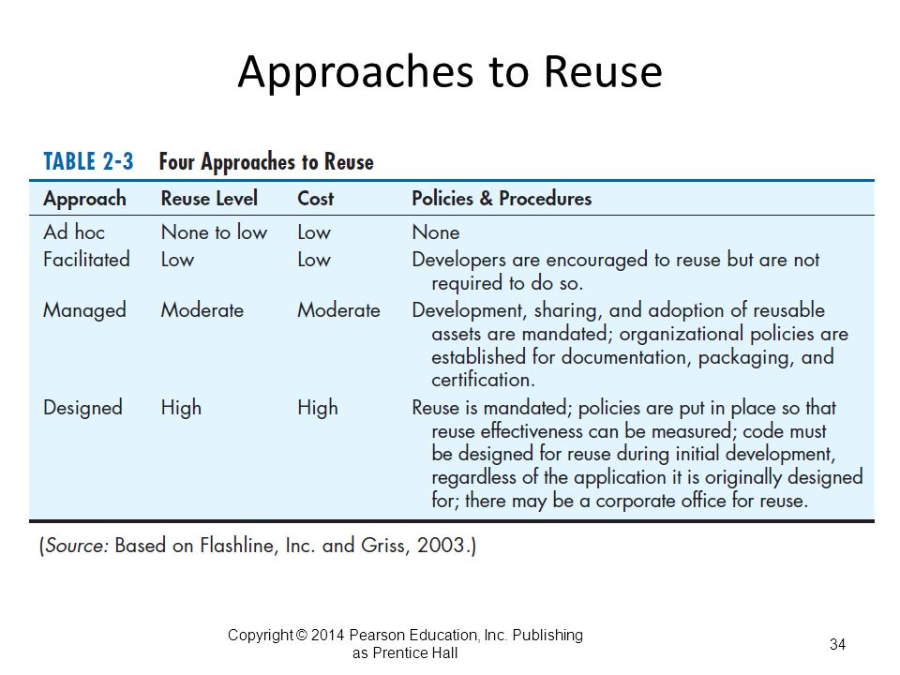

**Managing the information systems project**

* Project manager is a system analyst with a diverse set of skills – management, leadership, technical conflict management and customer relationship – who is responsible for initiating, planning, executing and closing down a project.

**Project Management Process involves:**

1. Initiating the project
2. Planning the project
3. Executing the project
4. Closing doon the project

**Common Activities and Skills of a Project Manager**

* **Leadership:** Communication, relation between management, users and developers, assigning activities
* **Management:** Defining and sequencing activities, communicating expectations, assigning resources to activities monitoring outcomes.
* **Customer relations:** Interpreting system requests and specifications, site preparation and user training.
* **Conflict management:** Goal setting, compromising, smoothing our personality differences.
* **Technical problem solving:**
* **Team Management**
* **Risk and change management:** Risk and opportunity identification and assessment, forecasting.

**Project Management activities:**

1. Customer and management
2. Technological change
3. System development life cycle
4. Organizational change and complexity
5. Contractors and vendors
6. Managing people
7. Methodologies and tools
8. Time and resource constraints
9. Documentation and communication

**Initiating a Project**

Activities are performed to assess the size, scope and complexity of the project and to establish procedures to support later project activities.

**Types of activities done in this phase are:**

1. **Establishing project initiation team:** Organization an initial core of project team members to assist in accomplishing the project initiation activities.
2. **Establishing a relationship with customers**: Understanding of our customer builds stronger partnership and higher level of trusts
3. **Establishing the project initiation plan:**
   1. It defines the activities required to organize the initiation team while it is working to define the goals and scope of projects
   2. Define deliverables and project steps and set deadlines and how they communicate.
   3. Initiation plan include agendas for several meeting.
   4. This step led to the creation of their SSR form system service request
4. **Establishing Management procedures:** When establishing procedures, you are concerned with developing team communications and reporting procedures, Job assignments and rules, project change procedures and determine how project funding and billing will be handled.
5. **Establishing project management environment and project workbooks**
   1. Collecting and organizing the tools that were used during project management and to construct project workbook.
   2. Project workbook is a repository for all project correspondence, inputs, outputs, deliverables, procedures, and standards established by the project teams.
   3. Project workbook is used by all team members and useful in project audits, orientation of new team members, communication with management and customers, identifying future projects and performing post-project reviews.

**Project Workbooks**

1. Project overview
2. Initiation plan and SSR
3. Project scope and risks
4. Management procedures
5. Data descriptions
6. Process descriptions
7. Team Correspondence
8. Project Charter
9. Project schedule
10. **Developing Project Charter:**

* Project charter is a short high-level document prepared for the customer that describers what the project will deliver and outlines many of key elements of project.
* Project charter

1. Project title and date of authorization
2. Project manager name and contact info
3. Customer name and info
4. Project start and completion dates
5. Key stakeholders, project role and responsibilities
6. Project objectives and description
7. Key assumption or approach
8. Signature section for key stakeholders

*Note: Before moving to next phase, the work performed during project initiation is reviewed at a meeting attended by management, customers and project team members*

**Planning the Project**

Project planning focuses on defining clear, discrete activities and the work needed to complete each activity within a single project.

**Types of activities**

1. Describing project scope, alternatives and feasibility: ***understand content and complexity of project****.*
2. Dividing the project into manageable tasks
3. Estimating resource and creating a resource plan
4. Developing a preliminary schedule: ***Can be represented by Gantt Chart, network diagram.***
5. Developing a communication plan
6. Determining project standards and procedures
7. Identifying and assessing risk
8. Creating a preliminary budget
9. Setting a Baseline project plan

**Executing the plan**

Project execution puts the baseline project plan into action.

**Some activities are:**

1. **Executing the Baseline project plan.**
   1. You initiate the execution of project activities acquire and assign resources, orient and train new team members, keep the project on schedule and ensure the quality of project deliverables
2. **Monitoring project progress against the Baseline project plan**
   1. If the project gets ahead or behind schedule you may have to adjust resources, activities, and budgets.
   2. Monitoring project activities can result in modifications to the current plan
3. **Managing changes to the Baseline projects plan**
4. **Maintaining the project workbook**
5. **Communicating the project status**

**Closing down the project**

Project closedown focuses on bringing a project to an end.

**Activities:**

1. Closing down the project
2. Conducting post-project reviews
3. Closing the customer contract

**Project Schedule**

1. Gantt Chart
2. Network Diagram
3. PERT

**Unit – 2**

**Planning**

Planning phase of the SDLC is also when the project plan is developed that identifies, priorities and assigns the tasks and resources required to build the structure for a project.

Primary goal is to make sure that the development process is smooth and final results are top-quality and it also helps to reduce tie, costs and other resources for the client.

Planning consists of project identification and selections and project initiation and planning.

During project identification and selection, a senior manager, a business group, as IS manager, or a steering committee identifies and assesses all possible systems development projects that an organization unit could undertake.

**Process of Identifying and selecting IS development projects**

* Project identification and selection consists of three primary activities:
  1. Identifying potential development projects
  2. Classifying and ranking IS development projects
  3. Selecting IS development projects

1. **Identifying potential development projects**

|  |  |
| --- | --- |
| **Selection Method** | **Characteristics** |
| Top Management | Greater strategic focus.  Largest Project size.  Longest project duration.  Enterprise-wide consideration. |
| Steering committee | Cross-functional focus.  Greater organizational change.  Formal cost-benefit analysis.  Larger and riskier projects. |
| Functional Area | Narrow, non-strategic focus.  Faster development.  Fewer users, management layers and business functions involved. |
| Development Group | Integration with exiting system focus.  Fewer development delays.  Less concern with cost-benefit analysis. |

1. **Classifying and ranking IS development projects:**

* Focuses on assessing the relative merit of potential projects.
* It can be done by top managers, a steering committee, business units or IS development group.
* Some project evaluation method that widely used for assessing information systems development projects.

|  |  |
| --- | --- |
| **Evaluation Criteria** | **Description** |
| Value chain Analysis | Extent to which activities add value and costs when developing products and / or services. |
| Strategic Alignment | Extent to which the project is viewed as helping the organization achieve its strategic objectives and long-term goals. |
| Potential Benefits | Extent to which the project is viewed as improving profits, customer service, and so forth, and the duration of their benefit. |
| Resource Availability | Amount and type of resources the project requires and their availability. |
| Project size/duration | Number of individuals and the length of time needed to complete the project. |
| Technical Difficulty / Risks | Level of technical difficulty to successfully complete the project within given time and resource constraints. |

1. **Selecting IS development projects:**

* Project selection is a process of considering both short and long terms projects and selecting those most likely to achieve business objectives.
* Numerous factors must be considered when making project-selection decision.
* Perceived and real needs of the organization.
* Existing system and available resources
* List of ongoing projects
* Current business conditions
* Evaluation criteria
* Decision from numerous factors can have numerous outcomes.
* Accept project
* Reject project
* Delay project
* Refocus project
* Proof of concept

**Corporate and information system planning:**

Corporate strategic planning and information systems planning, two processes that can significantly improve the quality of project identification and selection decisions.

Corporate strategic planning 3 steps process:

1. **Current Enterprise**

Focuses on gaining an understanding of the current enterprise.

1. **Future enterprise**

Top management must determine where it wants the enterprise to be in the future.

1. **Strategic plan**

Finally, after gaining an understanding of current and future enterprise, a strategic plan can be developed to guide this transition.

**Corporate Strategic planning**

* An ongoing process that defines the mission, objectives, and strategies of an organization.
* Once a company or organization has defined its mission objectives, a competition strategy can be formulated.
* Competitive strategy is the method by which an organization attempts to achieve its mission and objectives.

**Information System Planning (ISP)**

Second planning process that can play a significant role in the quality of project identification and selection decisions is called ISP.

ISP is an orderly means of assessing the information needs of an organization and defining the systems database and technologies that will best satisfy those needs.

ISP processes have 3 steps:

1. Current situation
   1. Listing of manual and automated processes
   2. Listing of manual and automate data
   3. Technology inventory
   4. Human resources inventory
2. Future situation
   1. Blueprints of manual and automated processes
   2. Blueprints of manual and automated data
   3. Technology blueprints
   4. Human re